January 2024 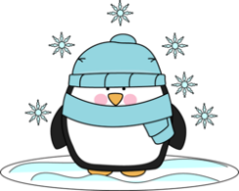
Sunday | Monday | Tuesday | Wednesday | Thursday | Friday | Saturday
 | 1  NO SCHOOL | 2  NO SCHOOL  GBB-Home-Norway 5:15pm | 3  Smiles on Wheels | 4  BBB-Home-Bark River 5:15pm  Smiles on Wheels | 5  GBB at Bark River 5:00pm | 6  Women’s Basketball Tournament
7 | 8 | 9  BBB-Home-Hannahville 5:15pm | 10 | 11  BBB-Home-Mid Pen 5:15pm | 12  GBB at Munising 5:00pm | 13  Elementary Girls Basketball Tournament
14 | 15 | 16 | 17 | 18 | 19 | 20
 | BBB at Munising 5:00pm | GBB-Home-Rapid River 5:00pm | Exams  Board Meeting | Exams | *Noon Release-PD  *Exams  *End of Semester 1  *GBB at Mid Pen 5:00pm | BBB @ The Herd Arena-Oshkosh 12:15pm
21 | 22 | 23 | 24 | 25 | 26 | 27
 | GBB-Home-North Central 5:15pm | BBB-Home-Superior Central 5:15pm |  |  | BBB at Crystal Falls 5:30pm
28 | 29 | 30 | 31
 | GBB-Home-Crystal Falls 5:15pm | BBB-Home-North Central 5:15pm – Purple Night

